*This is a draft proposal for a “Makerspace” in Lowell called “Lowell Makes”*

# Vision

A membership-controlled collaborative space equipped with a wide variety of tools, machines, materials, computers and other resources where individuals can gain and practice modern skills with state-of-the-art technology, access to resources they could not otherwise, and a community of creative- minded people who make all kinds of things. “Art is the Handmaid of Human Good” is both the City of Lowell’s motto, and a reminder of Lowell’s rich industrial and artistic history as our inspiration.

The space would be used for brainstorming, visioning, problem solving, design, prototyping, custom fabrication and repair. As a “maker space,” in addition to routine use by members, the space would also be used for classes and workshops for both members and visitors in a wide variety of subjects.

Classes would be led both by members and invited visitors who have knowledge of skills, trades and technologies. They could include things such as rudimentary carpentry and electrical wiring, or advanced microcontroller programming and robotics. Anything creative can happen here.

Primary operating expenses would be rent, insurance and utilities, which would be funded wholly by membership payments and space rentals. Standard memberships would be approximately $100 per month, with discounted memberships available for students and others with limited financial resources who want to learn, and become part of the creative economy and/or a creative member of society.

Members would have 24x7 access through the use of electronic tokens which also unlock restricted equipment available for use by authorized individuals who have had the proper training. A limited amount of space would be available for a fee to house lockable cabinets owned by members to hold materials and equipment not generally available for shared use.

Equipment and resources available to members and authorized visitors would include things such as 3D printers, laser etchers and cutters, CNC mills, plus more traditional shop tools such as drill presses and a variety of saws. Also available would be computer workstations loaded with best-of-breed software for design and fabrication.

Outreach will be done to manufacturers of specialized equipment and software, such as 3D printers and CAD software, to secure donated or discounted items with training. The long-term interest by these businesses to have as many people skilled with their technology as possible is their primary motivation.

Lowell Makes will have convenient access to highways, parking lots and spaces, public transit and bicycle sharing. It is modeled after Artisan’s Asylum in Somerville, MA and MakeIt Labs in Nashua, NH.

# The Launch Team

The people driving this project all live in Lowell, are involved in their communities, and care deeply about the city and its future. They are:

* John Noto: Scientist and Engineer, Founder and President of Scientific Solutions
* Eric Sack: Video Technologistics at Lowell Telecommunications Corporation
* Kamal Jain: Technology and infrastructure operations specialist

# Current Status

The launch team has been investigating possible sites for Lowell Makes, and has surveyed three potential locations: Gates Block, Mill No. 5, and Boott Mill; additional sites are being reviewed.

Some of the considerations for potential sites include geographic location, availability of loading areas, the ability to do welding and other, more industrial processes, accessibility and parking, and rent.

# Financial Overview

It is estimated that monthly operating expenses for rent and utilities will be between $3,000 and $4,000. Ideally, no lease will be signed without at least 12 months of cash secured by the launch team through pre-paid membership fees, donations and grants.

An unknown, potentially significant operating expense is insurance to provide coverage in the event of accident or injury. Actual insurance costs from Artisan’s Asylum in Somerville, MA are approximately $1,000 per month and they are a significantly larger operation than Lowell Makes will be in its first year.

Staffing costs are not being factored-in at this time as the belief is that members can come and go on their own, and volunteers will be available at times to assist, provide information, etc.

|  |  |  |
| --- | --- | --- |
| **Rent/Insurance/Utilities** | **12-month operating cash need** | **24-month operating cash need** |
| $5,000 | $60,000 | $120,000 |

Startup costs would include some equipment, high- and low- voltage wiring for power and data service distribution, and build-out of things such as a noise-isolating room for loud equipment. Startup costs can be minimized by having members do work and contribute materials as they are able to, which is consistent with the mission and vision of Lowell Makes.

# Launch Requirements

In order to launch Lowell Makes, commitments for adequate funding to cover the financial considerations above must be secured.

In addition, to prove the viability of the concept of donation of high-tech hardware and software, no financial commitments or encumbrances will be made by the launch team until and unless commitments to donate hardware and software are secured.

Members of the launch team are willing to contribute seed capital toward the launch expenses

# Supplemental Material and Notes

Please see photos of one of the buildings and spaces under consideration (Gates Block), bearing in mind that there are several other potential locations which are equally viable, if not more so.

# Floor Plan

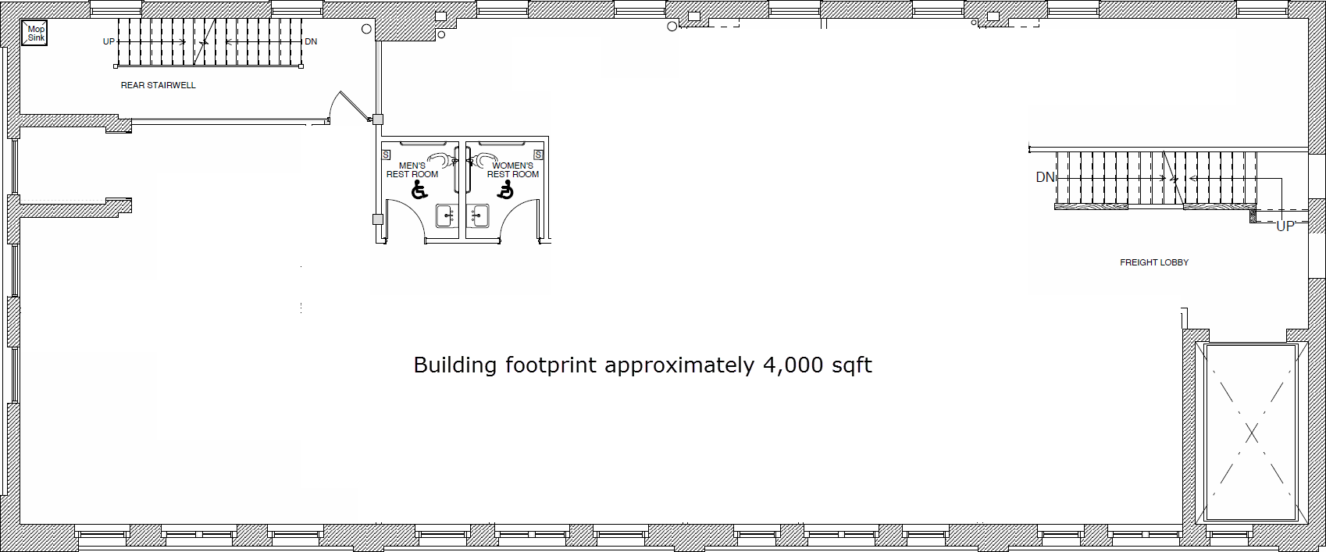

# Photos

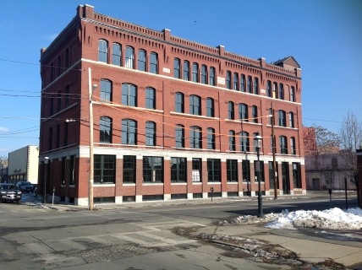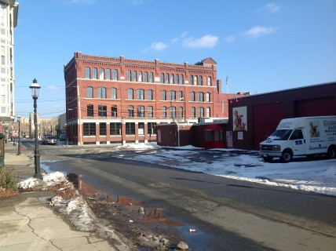

Photos continue on subsequent pages.

